Calculating Halstead Metrics

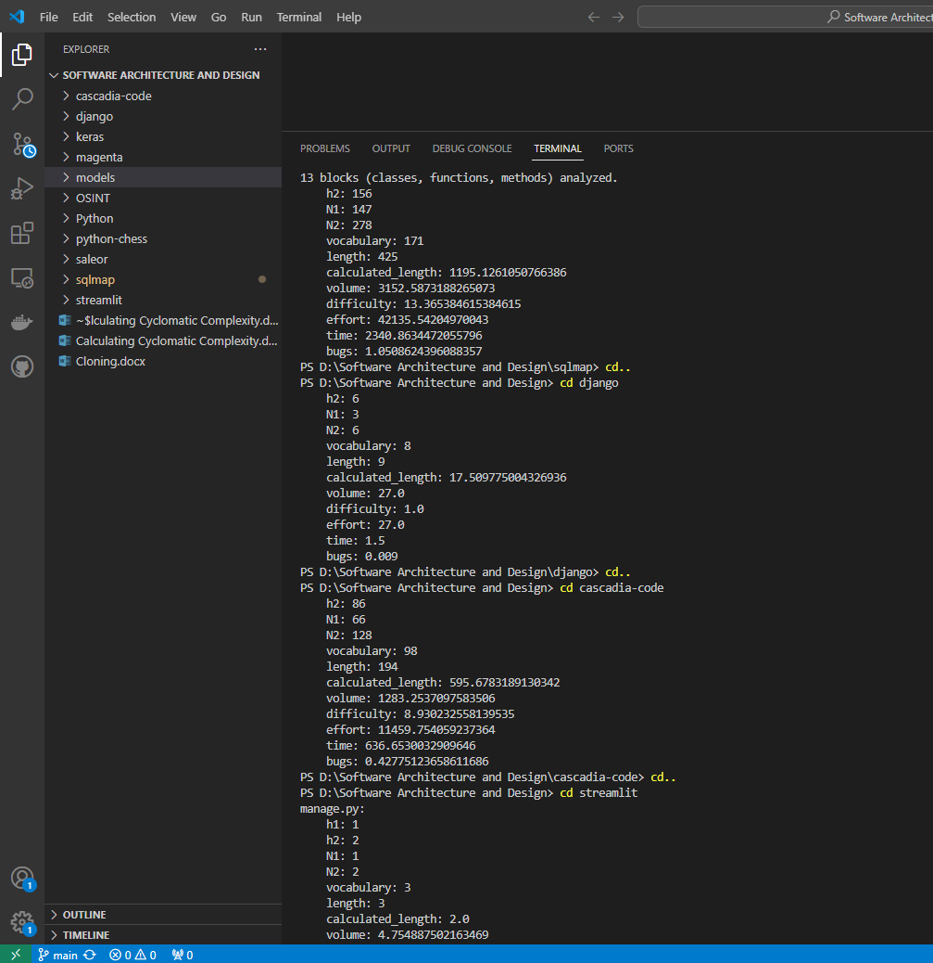

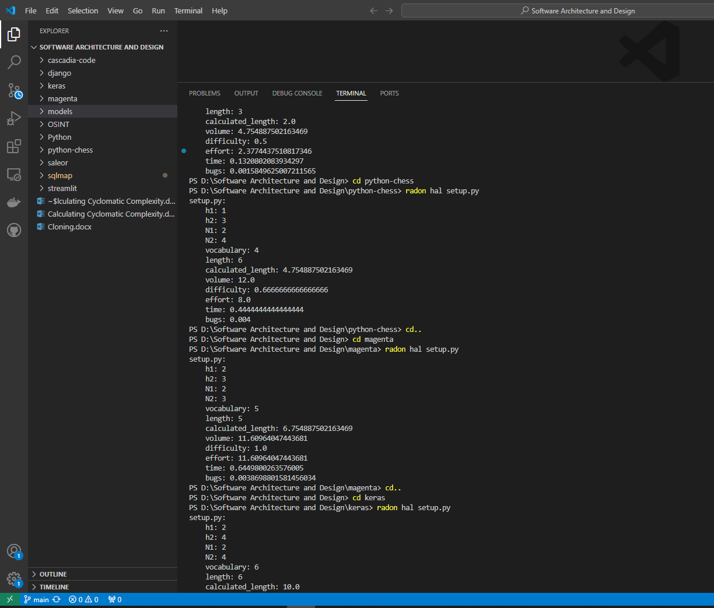

PS D:\Software Architecture and Design\sqlmap> radon hal sqlmap.py

sqlmap.py:

h1: 15

h2: 156

N1: 147

N2: 278

vocabulary: 171

length: 425

calculated_length: 1195.1261050766386

volume: 3152.5873188265073

difficulty: 13.365384615384615

effort: 42135.54204970043

time: 2340.8634472055796

bugs: 1.0508624396088357

PS D:\Software Architecture and Design\django> radon hal setup.py

setup.py:

h1: 2

h2: 6

N1: 3

N2: 6

vocabulary: 8

length: 9

calculated_length: 17.509775004326936

volume: 27.0

difficulty: 1.0

effort: 27.0

time: 1.5

PS D:\Software Architecture and Design\cascadia-code> radon hal build.py

build.py:

h1: 12

h2: 86

N1: 66

N2: 128

vocabulary: 98

length: 194

calculated_length: 595.6783189130342

volume: 1283.2537097583506

difficulty: 8.930232558139535

effort: 11459.754059237364

time: 636.6530032909646

bugs: 0.42775123658611686

PS D:\Software Architecture and Design\saleor> radon hal manage.py

manage.py:

h1: 1

h2: 2

N1: 1

N2: 2

vocabulary: 3

length: 3

calculated_length: 2.0

volume: 4.754887502163469

difficulty: 0.5

effort: 2.3774437510817346

time: 0.1320802083934297

bugs: 0.0015849625007211565

PS D:\Software Architecture and Design\python-chess> radon hal setup.py

setup.py:

h1: 1

h2: 3

N1: 2

N2: 4

vocabulary: 4

length: 6

calculated_length: 4.754887502163469

volume: 12.0

difficulty: 0.6666666666666666

effort: 8.0

time: 0.4444444444444444

bugs: 0.004

PS D:\Software Architecture and Design\magenta> radon hal setup.py

setup.py:

h1: 2

h2: 3

N1: 2

N2: 3

vocabulary: 5

length: 5

calculated_length: 6.754887502163469

volume: 11.60964047443681

difficulty: 1.0

effort: 11.60964047443681

time: 0.6449800263576005

bugs: 0.0038698801581456034

PS D:\Software Architecture and Design\keras> radon hal setup.py

setup.py:

h1: 2

h2: 4

N1: 2

N2: 4

vocabulary: 6

length: 6

calculated_length: 10.0

volume: 15.509775004326936

difficulty: 1.0

effort: 15.509775004326936

time: 0.861654166907052

bugs: 0.005169925001442312